CSIS3744
Practical Assignment 2
Student Number: 2021332339

1. Subnetting

1.3 ABC ISP
ABC ISP's server has been assigned the IP address 146.182.1.254, and the network must be divided into 8 subnets.
1.3.1 Default subnet mask for ABC ISP's network
146 falls in the 128–191 range, which is the Class B range. The default subnet mask for a Class B network is therefore 255.255.0.0 (/16).
1.3.2 New subnet mask for the proposed subnets
8 subnets are required. Since 2³ = 8, 3 bits must be borrowed from the host portion of the address.
New prefix: /16 + 3 = /19
The third octet becomes 11100000 = 128 + 64 + 32 = 224.
Subnet mask: 255.255.224.0
1.3.3 Usable addresses per subnet
Host bits remaining = 32 − 19 = 13.
Usable hosts per subnet = 2¹³ − 2 = 8,192 − 2 = 8,190
1.3.4 Total number of machines the whole network can host
8 subnets × 8,190 usable addresses = 65,520 machines
1.3.5 Server IP address in CIDR notation
146.182.1.254/19
1.3.6 First two subnets
Block size = 256 − 224 = 32, so each subnet steps up by 32 in the third octet. The broadcast address is one address below the start of the next subnet, and the usable range spans everything in between.
Subnet | Network Address | Broadcast Address | Usable Host Address Range
1 | 146.182.0.0 | 146.182.31.255 | 146.182.0.1 – 146.182.31.254
2 | 146.182.32.0 | 146.182.63.255 | 146.182.32.1 – 146.182.63.254

1.4 ZEM TV
ZEM TV's network address is 192.168.115.0/25.
1.4.1 IPv4 class
192 falls in the 192–223 range, which is the Class C range (default /24).
1.4.2 Bits borrowed from the host bits
/25 minus the default /24 means 1 bit has been borrowed to create the subnets.
1.4.3 Subnet mask for ZEM TV
Borrowing 1 bit makes the last octet 10000000 = 128.
Subnet mask: 255.255.255.128
1.4.4 Network address, broadcast address and usable host range for each subnet [4]
Subnet | Network Address | Broadcast Address | Usable Host Address Range
1 | 192.168.115.0 | 192.168.115.127 | 192.168.115.1 – 192.168.115.126
2 | 192.168.115.128 | 192.168.115.255 | 192.168.115.129 – 192.168.115.254

1.5 ZEM TV Network Simulation
The ZEM TV network was built and configured in Cisco Packet Tracer using the guidelines from the video tutorial.
1.5.1 Create the network topology [2]
Equipment used:
- 1 × Router 2911
- 2 × Switch 2960-24TT
- 4 × PCs (2 per subnet, connected to gateway = first usable host address in each subnet)
- Straight-through copper cable connections (FastEthernet0)
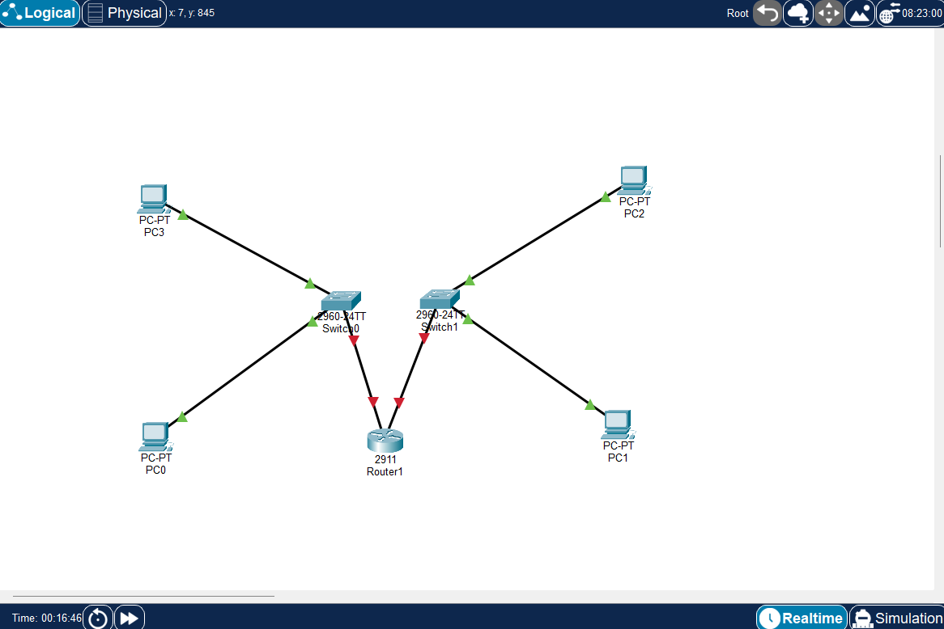
Figure 1: Initial logical topology for ZEM TV's network
1.5.2 Perform IP configuration on the devices [2]
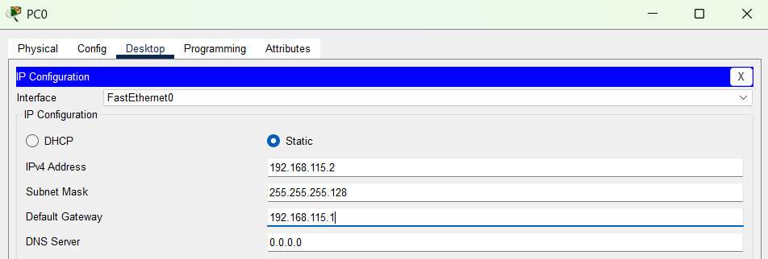
Figure 2: IP configuration — PC0
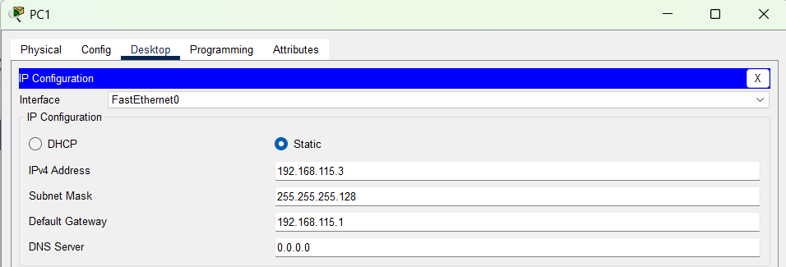
Figure 3: IP configuration — PC1
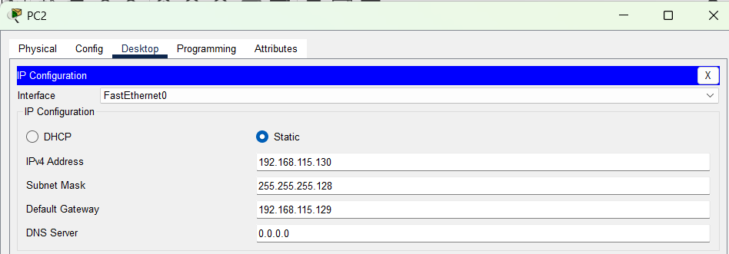
Figure 4: IP configuration — PC2
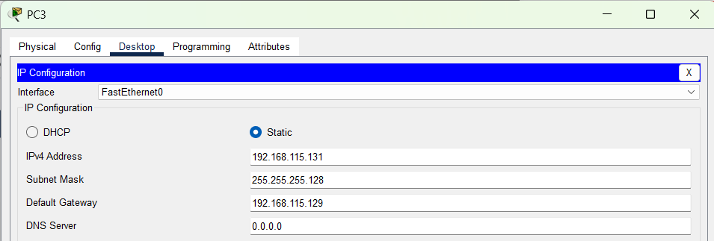
Figure 5: IP configuration — PC3
1.5.3 Test the connection in each subnet
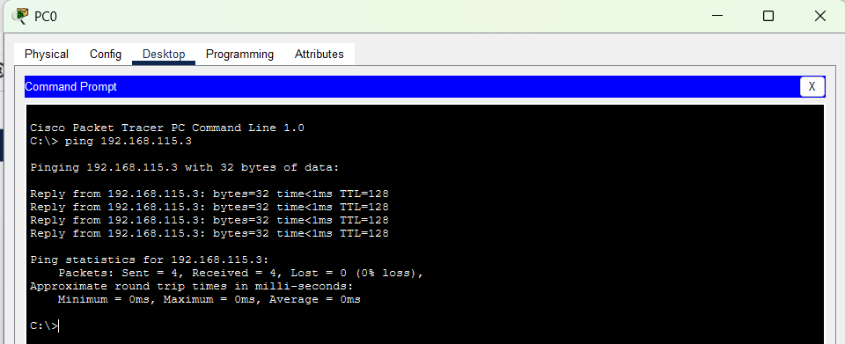
Figure 6: Pinging within the subnet, PC0 → PC1
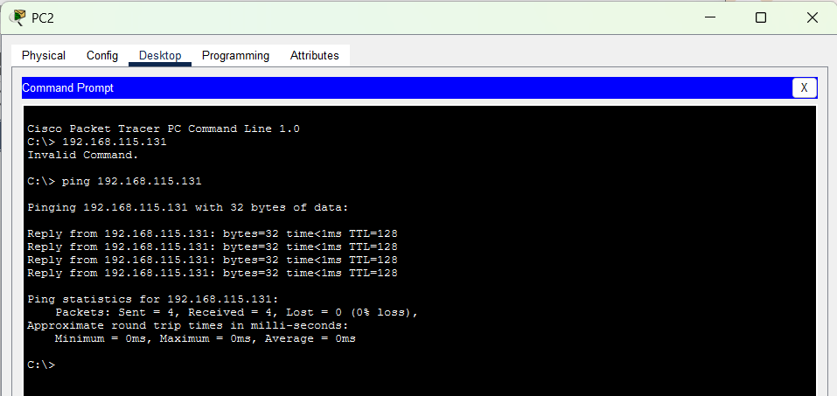
Figure 7: Pinging within the second subnet, PC2 → PC3
1.5.4 Perform router configuration
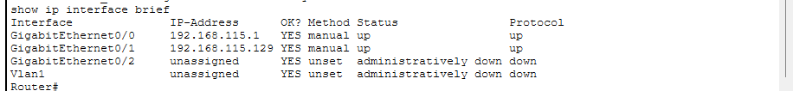
Figure 8: 'show ip interface brief' confirming the router configuration was successful
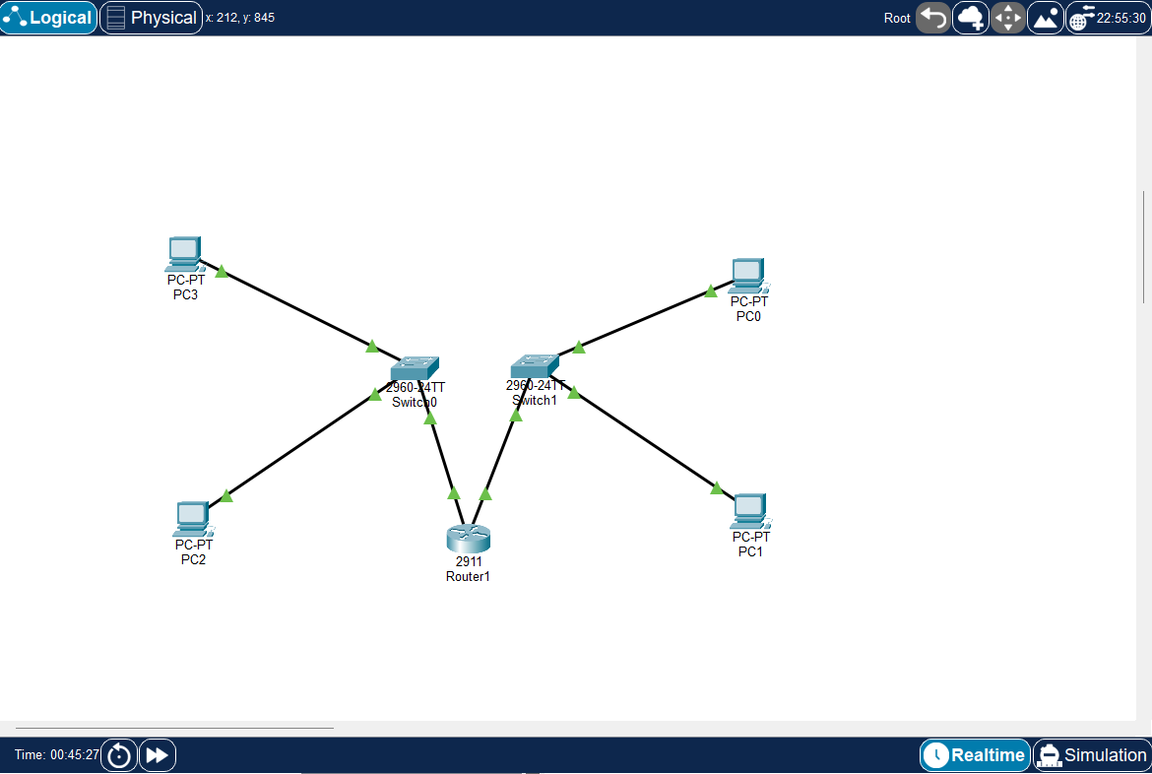
Figure 9: All connections shown active (green) in the topology
1.5.5 Test the connection between subnets
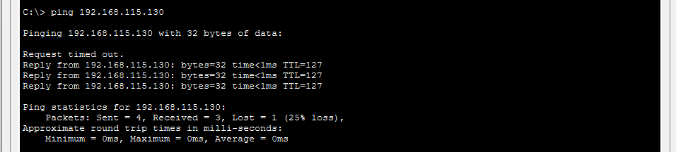
Figure 10: Confirming connectivity across subnets once the router was configured

